How to Draw a Tropical Beach Scene
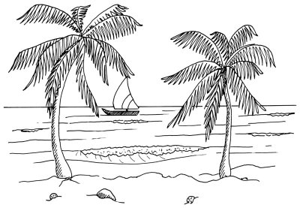

The sun shines and palm trees sway in the breeze in this tropical beach scene. Learning to draw this landscape can be as relaxing as being in it.

In this section, we'll show you how to draw this tropical beach landscape. You can draw it freehand while looking at your computer monitor, or you can print out this page to get a closer look at each step.

Here, we'll show you an illustration of each step and then give you a description of how to draw it. Follow the red lines in each illustration to learn exactly what to draw in that step. The lines drawn in previous steps are shown in gray.

To start drawing the tropical beach landscape, place a light horizon line in about the middle of the page.



Step 1: Place a light horizon line in about the middle of the page. Draw the hull of a sailboat with a long rectangle that has an upturned and sharply pointed end or bow. Make the sail using a triangle with two curved sides and a flat bottom. Draw a second, gently curving line below the boat to represent the shoreline.

To draw a tropical beach landscape, show waves near the shoreline with pairs of squiggly lines.

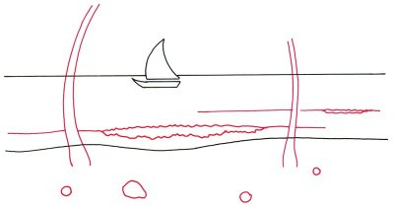
Step 2: Shape the trunks of palm trees with two sets of curving lines that taper as they go up. Sketch some rounded shapes on the sandy beach for coconuts and rocks. Show waves near the shoreline with pairs of squiggly lines. Extend each wave with single lines.

To draw a tropical beach landscape, add jagged lines near the trees and rocks to give contour to the beach.

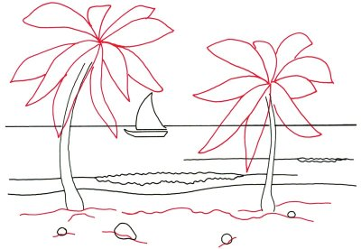
Step 3: Sketch in the basic outline for the large leaves at the tops of the palm trees. Add jagged lines near the trees and rocks to give contour to the beach.

To draw a tropical beach scene, use long, jagged lines to give form to the palm leaves.

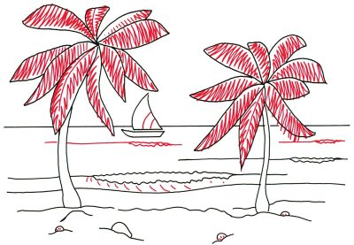
Step 4: Give form to the palm leaves with long, jagged lines, as shown. Use a pair of curved lines to make stripes on the boat's sail. Sketch a few more waves on the surface of the sea. Put in short lines on the front surface of the first wave. Add very short lines to the coconuts.

To complete your tropical beach drawing, add dots and squiggles to show the foam of a breaking wave.

Step 5: Use a series of diagonal parallel lines to shade one side of the tree trunks, the sail boat, and the rock. Complete the drawing with dots and squiggles to show the foam of a breaking wave. Add several lines to the surface of the water.

Your landscape drawing is finished! Even if you don't get it right the first time, keep practicing until you're happy with your drawing. A stone path leads to a charming country church in our next section. Keep reading to learn how to draw this scene in just five steps.

